Social Media Engagement due to COVID-19
Student’s Name
Institutional Affiliation

Table of Content
Cover Page……………………………………………………………….1
Table of Content…………………………………………………………2
Executive Summary……………………………………………………...3
Introduction……………………………………………………………...4
Zoom Meetings…………………………………………………………..4-6
Online Marketing………………………………………………………...7-8
Conclusion……………………………………………………………….9
References……………………………………………………………….10

Executive Summary
When the COVID-19 pandemic was discovered in Wuhan, China, in December 2019, people did not expect the disease to cause havoc on the global scene. The disease gained momentum, and within a couple of months, it had engulfed the whole world. The disease brought businesses to a standstill due to travel bans, lockdowns, and social distancing to curb its spread. Many businesses were halted while millions of people lost their livelihoods. The most creative businesses, especially those that offered basic needs and entertainment, opted for social media platforms to remain relevant in their businesses. One of the ways the businesses used was the use of Zoom meetings. Companies used such meetings to discuss business opportunities, operations, and also for management purposes. Companies, for instance, Apple, used Zoom meetings to coordinate the work-from-home activities. Zoom company saw its users swell from 10 million in 2018 to over 300 million users in 2020. Also, zoom meetings were used to sell services, for instance, yoga classes and even lectures. Also, companies took advantage of the social media platforms to engage in online marketing to sell their products and services. Restaurants used, for instance, Swizzler Restaurant in the USA used to make food deliveries to its customers. Also, entertainment companies used such a rare opportunity to quench the thirst of entertainment lovers from their sitting rooms' comfort. Such companies included Netflix and also those that showcase Yoga. The Digital Greg also live-streamed the Digital Drag Fest that features a queens group that entertained people online through live streaming. From such observations, it is clear that some businesses became more creative by engaging social media platforms to remain relevant in the world of business as they wait for the world economy to open again.

Social Media Engagement due to COVID-19
Introduction
When the novel COVID-19 pandemic emerged in the Wuhan market in China in 2019 December, it was equated to a normal respiratory disorder that could be dealt with using over-the-counter medication. The strange disease with influenza-like characteristics prompted China's government to notify the World Health Organization and Center for Disease Control about the pandemic. Within three months, the pandemic had circumnavigated the globe. The most worrying fact pertains to the volatile nature of its spread via contact with infected droplets and services. The disease threatened nations' public health by causing deaths and rendering people unproductive (Kalogiannidis, Chatzitheodoridis & Kontsa, 2020). Also, many businesses were brought to a standstill as companies closed to curb the rapid spread. Many governments advocated for travel bans, especially to the epicenters of the pandemic. Besides, widespread business interruptions were witnessed in major business veins, such as labor markets and global supply chains. Many people lost their long-term livelihoods, including their business ventures. Businesses worldwide became creative and engaged social media platforms during the pandemic to enhance their chances of survival. The methods include online marketing and service provision and the use of zoom meetings.
The use of Zoom meetings
A zoom meeting entails the use of a video conferencing service that is cloud-based. The service enables people to hold a meeting virtually by using electronic gadgets, for instance, smartphones and computers. The service also allows the recording of the coverage for future use. The initiator creates a link and invites members to join by the use of a smartphone or webcam. Ever since the outbreak of COVID-19, governments' requirement for businesses to close down and practice social distancing forced many companies to remain relevant by the use of zoom meetings, which became a gold mine. Many businesses, both small and large, flocked zoom meetings to hold regular business meetings and discussions. In general terms, Zoom currently has over 300 million participants compared to 10 million participants in 2018 (Business of Apps, 2021). The swelling is attributed to the shift to online meetings by businesses since the spark of COVID-19. Businesses use the meetings to discuss business matters, for instance, challenges, possible solutions, and market penetration.
Most Businesses utilize Zoom meetings to showcase their classes. An excellent example is online zoom lectures and also yoga classes. Zoom recorded an increase in revenue from $167 million in the third quarter of 2020 to $777 million in 2021 (Business of Apps, 2021). Companies that used work-from-home strategy, for instance, Apple, could also use Zoom meetings to discuss company business ideas and progress (Sheth, 2020). The images below indicate how businesses utilize social media to communicate through zoom meetings (Business of Apps, 2021).

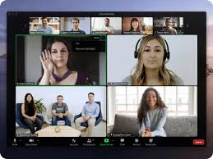
Figure 1 A zoom meeting by Norgine Limited employees.

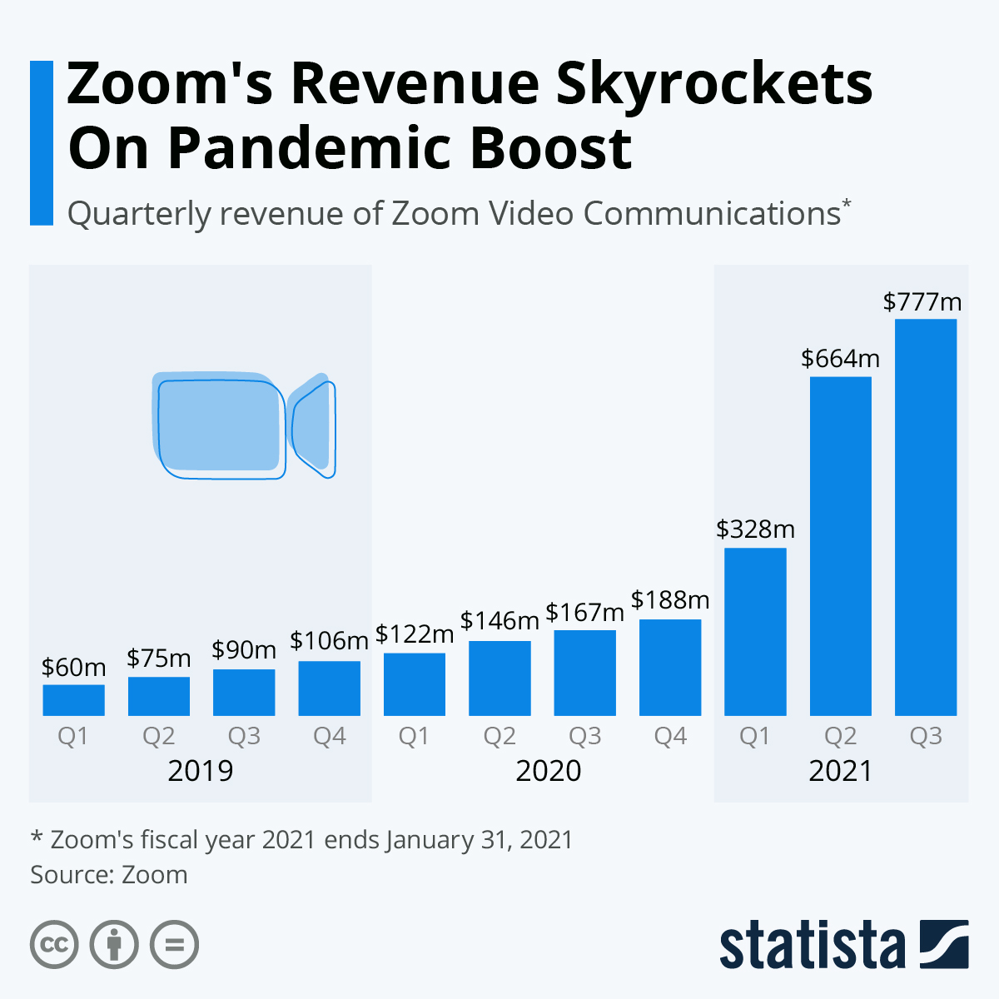
Figure 2 The use of Zoom from 2019 and 2021


Figure 3. Online entertainment during the lockdown.
Online marketing and service provision during the COVID-19 pandemic
The outbreak of COVID-19 flipped people's lives upside down due to restricted traveling and minimum interactions. Many people were forced to remain indoors and at the same time in need of basic needs and other secondary requirements that make life complete (Di Domenico et al., 2020). Online marketing came in handy as the best tool to reach customers and also enable businesses make sales. Companies made a move to stabilize their activities through the engagement of online marketing to sell their products. Consumers get emersed in web searching for the goods and services they need. COVID-19 saw a shift in consumer preferences and also behavior. This came as the best moment for digital marketers to engage and rt them to enhance goods and services. Companies adopted home delivery services to reach their customers. One such example is cabs' use to deliver food and food supplies to customers by Sizzler restaurant in the United States of America.
The food delivery service entailed a simple ordering service where the customer places an order for the chosen item to be delivered at his/her doorstep (Laguna et al., 2020). He/she also has to indicate the location for easy tracking. The restaurant included the delivery charges based on the distance to be covered. When the food is delivered, the package is paid via an account or a Reg card. Also, companies that used video marketing got a spot during the COVID-19 pandemic. It became an integral part of the digital era and a way of reaching potential customers and showing what businesses have in store. Businesses came up with video content and templates showing their products and services. Potential customers then request for the same. The businesses took advantage of the study, which revealed that people are more comfortable watching a 30-minute video than reading an entire blog. Also, people created videos and pictures to share what they were going through during the pandemic. They then posted them on various social media platforms, for instance, Facebook and Twitter. This formed a better chance for such individuals to get help from well-wishers and the government. On the other hand, the contents created a business opportunity for companies to seize the opportunity to land for business contracts of supplying the needed products and services (Hollebeek et al., 2020). Some of the products that were in high demand include facemasks and hand sanitizers.
Another common trend is the use of online-entertainment. The patterns of normal social lives of many people were altered into a degree of dormancy. Social avenues were closed; hence, people lacked entertainment opportunities to enjoy in social joints. Online entertainment came to the rescue of such a segment of the population in various ways. One of them was offering streaming services to kill boredom in those who stayed indoors with minimum activities. Some of the companies that engaged more during the pandemic include Netflix and the Digital Greg Festival. The avenues provided thrilling streaming of different entertainment kinds (Brindha, Jayaseellan & Kadeswaran, 2020). An excellent example is the Digital Drag Fest that features queens that entertained people online through live streaming.
Conclusion
To surmise, the outbreak of COVID-19 disrupted the livelihood of people and also businesses around the globe. Many people lost their job opportunities while many businesses were forced to close down due to government restrictions, for instance, a ban on travel, lockdown, and the practicing of social distance. Businesses became creative by adopting the use of social media as a way of maintaining their activities. Some of the ways employed by businesses include Zoom meetings to engage employees and the use of social media to market and sell goods and services. The goods could be sold via doorstep deliveries while services, for instance, entertainment, could be relayed to customers via live streaming.

References
Brindha, D., Jayaseelan, R., & Kadeswaran, S. (2020). Covid-19 Lockdown, entertainment and paid ott video-streaming platforms: A qualitative study of audience preferences. Mass Communicator: International Journal of Communication Studies, 14(4), 12-16.
Business of Apps. (2021). Zoom Revenue and Usage Statistics (2020). Business of Apps. Retrieved 28 February 2021, from https://www.businessofapps.com/data/zoom-statistics/.
Di Domenico, L., Pullano, G., Sabbatini, C. E., Boëlle, P. Y., & Colizza, V. (2020). Impact of lockdown on COVID-19 epidemic in Île-de-France and possible exit strategies. BMC medicine, 18(1), 1-13.
Hollebeek, L. D., Smith, D. L., Kasabov, E., Hammedi, W., Warlow, A., & Clark, M. K. (2020). Customer brand engagement during service lockdown. Journal of Services Marketing.
Kalogiannidis, S., Chatzitheodoridis, F., & Kontsas, S. (2020). Αn Eclectic Discussion of the Effects of COVID-19 Pandemic on the World Economy During the First Stage of the Spread. International Journal of Financial Research, 11(6).
Laguna, L., Fiszman, S., Puerta, P., Chaya, C., & Tárrega, A. (2020). The impact of COVID-19 lockdown on food priorities. Results from a preliminary study using social media and an online survey with Spanish consumers. Food quality and preference, 86, 104028.
Sheth, J. (2020). The business of business is more than business: Managing during the Covid crisis. Industrial Marketing Management, 88, 261-264.

